I can identify factors that can affect an organism’s ability to survive and thrive
I can research evidence to explain how characteristic animal behaviors affect the probability of successful reproduction of animals.

You will be making a Poke-style Card for the animal you picked yesterday! It includes basic information about your animal. Before you make card, fill in the rough draft below.
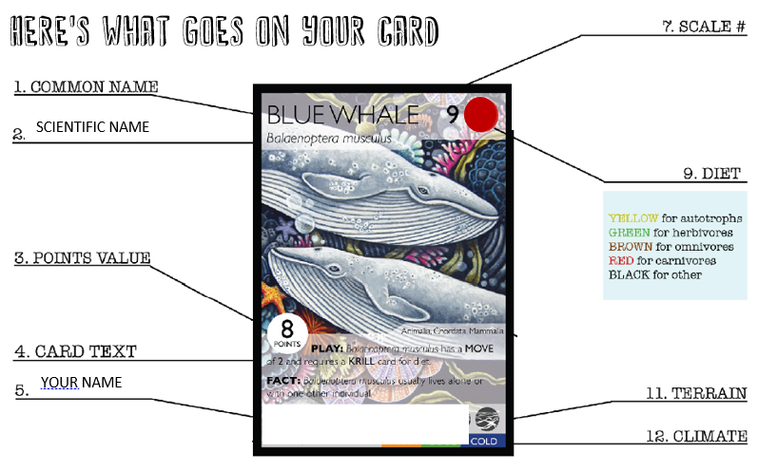

Rough Draft: Collect all the info you need about your animal and write it here! Mrs. Munn has some links to useful resources on MunnScience
ANIMAL PICTURE: You will be drawing your animal, so find a or two picture from google that you will use as a reference. Make sure your picture includes an adaptation that helps your animal survive.

  - COMMON NAME: the simple, everyday name for a particular species. Example: Human

  - SCIENTIFIC NAME: for a species, use the binomial nomenclature. Example Homo sapien

  - POINTS VALUE: the number of points that the card is worth. Fill in the chart and total your score:
My animal
Animal is an Herbivore | Add 1
Animal is a Omnivore | Add 3
Animal is a Carnivore | Add 5
Animal can fly | Add 2
Animal has sharp teeth | Add 1
Animal has natural camouflage | Add 3
Animal has spines | Add 2
Animal is poisonous or venomous | Add 4
When animal reproduces, it makes less than 2 offspring at a time (ex. Elephant or Human) | Minus 2
When animal reproduces, it makes more than 10 offspring at a time (ex. Salmon) | Minus 2
Adult animal is fluffy or cute | Minus 3
 | Total:

  - CARD TEXT: This is your animal's 'play.' It needs 2 and each needs to be explained in under 10 words. These are adaptations the animal has to survive and reproduce
Behavior Play: What are 3 Behaviors that it helps it survive. Chose the most distinctive one for your card
Special Structure: List 3 physical traits to help your animal survive. Chose the most distinctive one for your card

  - YOUR NAME: this is where you write your name

  - SCALE: the size of the species. Pick a number 1-9 to describe the size of your animal.
Uses these samples to help you pick a number: 1 – Ant 6 – Zebra 9 – Blue Whale

  - DIET: the type of food a species eats. See color legend above.

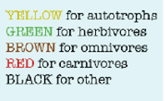 | Type of food eaten:  Color:

  - TERRAIN: What Biome does your organism live in?

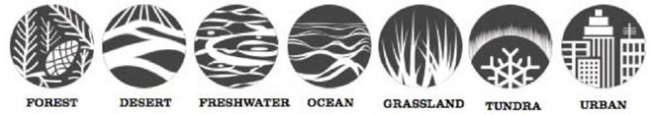 | Animal's Biome

  - CLIMATE: the climate preference of the organism: cold, cool, warm, or hot.

Animal Card
Once your have researched your animal, use this info to make an Animal Card.
Blank Card papers are on the back counter.
These are hand-drawn cards and written cards! Make sure they are clear and colorful!!
Use the sample card above and your rough draft to format your card

