W: 1. What are sources of electricity? List as many as you can.

- Where do people and other animals get energy to move around?

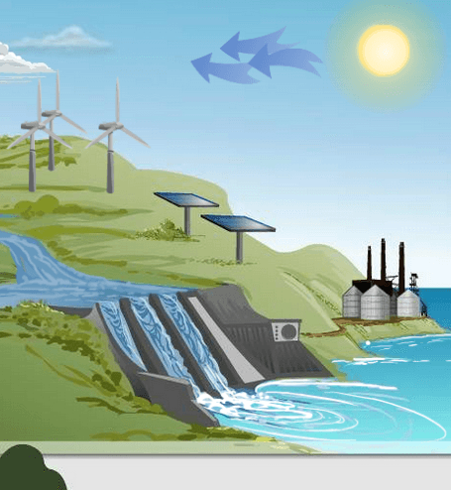
Station 1: Intro

- Which object converts sunlight into sugars? __________________

- Which object converts wind power to electricity? ________________

- Which object converts light to electricity? _____________________

- Which object converts electricity to sound? _____________________

Station 2: Energy Paths
- Fill in the Energy Path:

Sun → ______________ → ______________ → ______________

- Fill in 4 energy paths to power a toaster.

    - ______________ → ______________ → Toaster

    - ______________ → ______________ → ______________ → Toaster

    - ______________ → ______________ → ______________ → Toaster

    - ______________ → ______________ → ______________ → Toaster

- Where does each path begin? ____________________

- What would life on Earth be like without the Sun? _____________________________________________ _____________________________________________________________________________________

Station 3: Conversion
Energy Path | Energy conversion
____Sun_____  ____________  ____________  ____________ | Nuclear energy is converted to light and thermal energy.

Energy Path | Energy conversion
____________

____________

____________

____________

- Where in this activity (and in real life) do the following energy conversions occur?

Chemical to thermal to electrical current: _____________________

Gravitational potential to kinetic to electrical current: _____________________

Station 4: Renewable Energy
- What types of energy do not harm our environment?
Describe: Four examples of renewable resources are on your cards. These resources are produced all the time, so they will not run out. Read about each energy source, and then explain how each is produced in your own words.

  - Wind power: ____________________________________________________________________ _______________________________________________________________________________
  - Water power (also called hydroelectricity): ___________________________________________ _______________________________________________________________________________
  - Solar power: ____________________________________________________________________ _______________________________________________________________________________
  - Ethanol: ________________________________________________________________________ _______________________________________________________________________________

7th Science Page 4’s Minor Assignment
Name: _______________ Mod: ____ Date:________
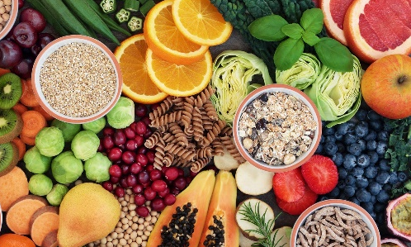 |  | - Circle one type of energy from each box to describe the food you eat.  Potential Energy Kinetic Energy Elastic Energy Chemical Energy Mechanical Energy Thermal Energy
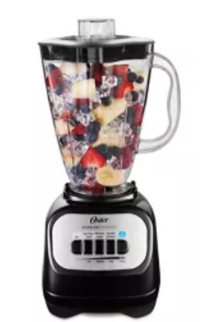 | - When this blender turns on. FIRST, You are using ____ energy. Circle your answer.  Electrical Thermal  Sound Mechanical  Light  - Which is NOT a form of Kinetic Energy this blender uses ever.  Electrical Energy Thermal Energy  Sound Energy Mechanical Energy  Light Energy
- Energy flows through systems and can convert between forms. Eventually, energy ends up as ___________________ energy

Science Page 4’s Minor Assignment
Name: _______________ Mod: ____ Date:________
- Circle one type of energy from each box to describe the food you eat.
Potential Energy  Kinetic Energy | Elastic Energy  Chemical Energy  Mechanical Energy  Thermal Energy

- When this blender turns on. FIRST, You are using ____ energy. Circle your answer.
Electrical Thermal
Sound Mechanical
Light

- Which is NOT a form of Kinetic Energy this blender uses ever.
Electrical Energy Thermal Energy
Sound Energy Mechanical Energy
Light Energy

- Energy flows through systems and can convert between forms. Eventually, energy ends up as ___________________ energy
Science Page 4’s Minor Assignment
Name: _______________ Mod: ____ Date:________
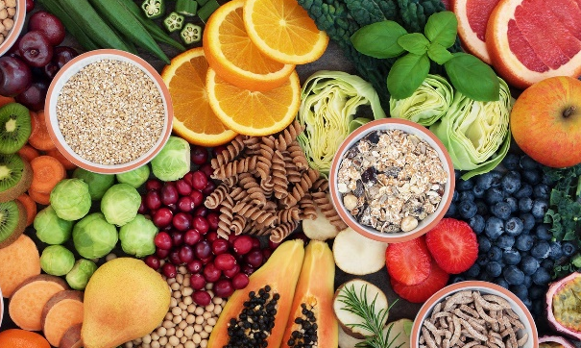 |  | - Circle one type of energy from each box to describe the food you eat.  Potential Energy Kinetic Energy Elastic Energy Chemical Energy Mechanical Energy
- When this blender turns on. FIRST, You are using ______ energy. Circle your answer.
Electrical Thermal
Sound Light

- Which is NOT a form of Kinetic Energy this blender uses ever.
Electrical Energy Thermal Energy
Mechanical Energy Light Energy

- Energy flows through systems and can convert between forms. Eventually, energy ends up as ___________________ energy
(Hint: check out #1 on the back of page 4!)

