I can identify factors that can affect an organism’s ability to survive and thrive
I can research evidence to explain how characteristic animal behaviors affect the probability of successful reproduction of animals.

You made a Poke-style Card for the animal you picked! It included basic information about your animal. NOW you need to research a plant that interacts with your animal and this will become a second card. Possible interactions:
  - If you have an herbivore, figure out what your animal eats.
  - Consider if you animal uses a plant for shelter
  - If you have carnivore, what does its prey eat?
  - If you have an aquatic animal, consider an algae, seaweed or kelp
  - What are dominant plants in the environment
  - Are their poisonous plants that it avoids

Before you make card, fill in the rough draft below.
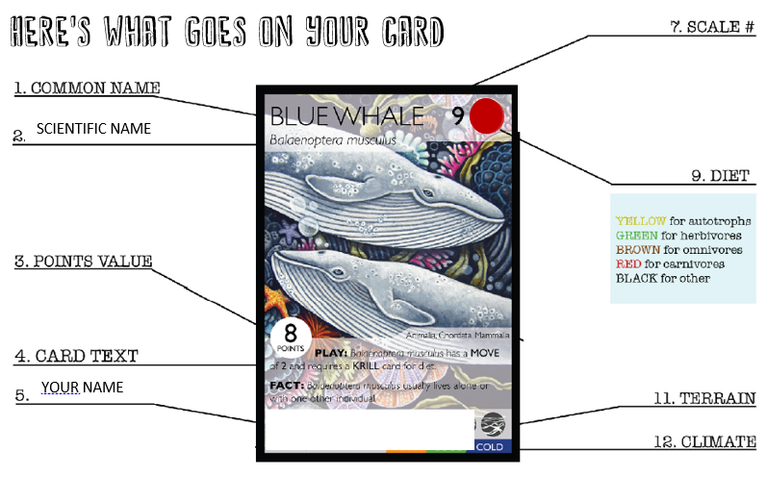

Rough Draft: Collect all the info you need about your animal and write it here! Mrs. Munn has some links to useful resources on MunnScience
PLANT PICTURE: You will be drawing your plant, so find a or two picture from google that you will use as a reference. Make sure your picture includes an adaptation that helps your plant survive.

  - COMMON NAME: the simple, everyday name for a particular species. Example: Human

  - SCIENTIFIC NAME: for a species, use the binomial nomenclature. Example Homo sapien
Genus | Species

  - POINTS VALUE: the number of points that the card is worth. Fill in the chart and total your score:
My animal
Plant is a sporophyte (spores) | Add 1
Plant is an gymnosperm (Needles and cones) | Add 3
Plant is an Angiosperm (fruit or flowers) | Add 5
Plant attracts insects to pollinate | Add 1
Plant has a wood stem or trunk | Add 2
Plant is pollinated by bird or bat | Add 3
Plant has thorns or spikes | Add 2
Plant is toxic or poisonous | Add 4
When plant reproduces, its seeds must be carried by animals for dispersal | Minus 2
When plant reproduces, seed can be dispersed by wind | Add 2
Plant is edible besides fruit or seeds | Minus 3
 | Total:

  - CARD TEXT: This is your plant's 'strategy.' It needs 2 and each needs to be explained in under 10 words. These are adaptations the plant has to survive and reproduce
Survival Strategies: What is one defensive strategy your plant uses to survive?
Special Structure: What is a physical trait to help your animal survive or reproduce.

  - YOUR NAME: this is where you write your name

  - Pollinators: include a list of specific species that aid in the pollination of your plant, if your plant is not aided by pollinators, explain how your plant reproduces.
Pollinators/Reproduction

  - SCALE: the size of the species. Pick a number 1-9 to describe the size of your animal.
Uses these samples to help you pick a number: 1 – Ant 6 – Zebra 9 – Blue Whale
Height of Plant | Scale Value
< 1 in. | 1
1 in. - 6 in. | 2
6 in. - 2 ft. | 3
2 ft. - 6 ft. | 4
6 ft. - 10 ft. | 5
10 ft. - 20 ft. | 6
20 ft. - 50 ft. | 7
50 ft. - 100 ft. | 8
100 ft. - 200 ft. | 9
>200 ft. | 10

  - DIET: the type of food a species eats. See color legend above.

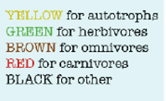 | Type of food eaten:  Color:

  - TERRAIN: What Biome does your organism live in?

Plant's Biome

  - CLIMATE: the climate preference of the organism: cold, cool, warm, or hot.

Plant Card
Once your have researched your plant, use this info to make a Plant Card.
Blank Card papers are on the back counter.
These are hand-drawn cards and written cards! Make sure they are clear and colorful!!
Use the sample card above and your rough draft to format your card

